Lecture # 18:

Objective:

* Database Connectivity (DISCONNECTED)
  + Selection Example

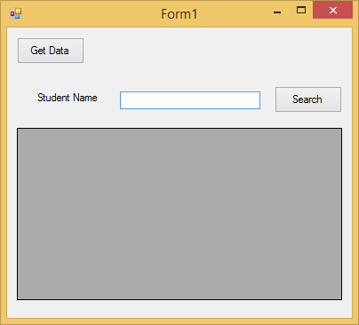

using System;

using System.Collections.Generic; using System.ComponentModel; using System.Data;

using System.Drawing; using System.Linq; using System.Text;

using System.Windows.Forms; using System.Data.SqlClient;

namespace WindowsFormsApplication1

{

public partial class Form1 : Form

{

public Form1()

{

InitializeComponent();

}

DataSet ds = new DataSet();

private void btndata_Click(object sender, EventArgs e)

{

string strCon = @" ";

SqlConnection con = new SqlConnection(strCon); con.Open();

string query = "Select * from stdinfo"; SqlCommand cmd = new SqlCommand(query, con);

SqlDataAdapter sda = new SqlDataAdapter(cmd); sda.Fill(ds);

}

private void btnsrch_Click(object sender, EventArgs e)

{

DataRow[] dr= ds.Tables[0].Select("name like '" + textBox1.Text + "%'");

foreach (DataRow item in dr)

{

dataGridView1.Rows.Add(item[0].ToString(), item[1].ToString());

}

}

}

}